August 23, 2010

RE: Important Changes

Dear Pharmacists:

As you are aware the Nova Scotia Prescription Monitoring Program (NSPMP) has been conducting Prescription Process Audits of all community pharmacies since April 2009. The purpose of this audit process is to ensure that the data submitted on-line by pharmacies reflects the information on the original prescription for monitored drugs and adheres to the requirements for submission of claims through the NSPMP on-line system.

The NSPMP has completed a review of the prescription process audit results and we have revised this process to better meet the required outcomes of the NSPMP’s Data Integrity Policy. The revisions to the audit process have been developed in consultation with the Nova Scotia College of Pharmacists and the NSPMP Board of Directors.

We all have a responsibility to ensure compliance is maintained with the Nova Scotia Prescription Monitoring Legislation which requires pharmacies to submit all claims for monitored drugs through the NSPMP on-line system. Compliance to the legislation ensures that the NSPMP is able to effectively carry out its mandate, “to promote the appropriate use of monitored drugs in Nova Scotia and to reduce the abuse or misuse of monitored drugs in the province.”

We understand this represents a change for your pharmacy and we do appreciate your patience and compliance to the new Prescription Process Audit. Please see the attached bulletin for a detailed explanation of the revised audit process. Should you have any concerns, please contact the NSPMP at 1-877-476-7767 or (902) 496-7123.

Sincerely,
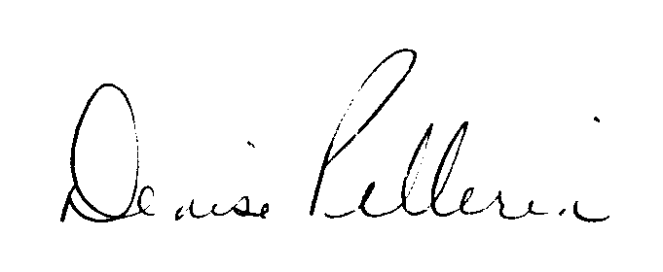

Denise Pellerin
Manager, Nova Scotia Prescription Monitoring Program

Data Integrity Policy and Guidelines

Prescription Process Audit

The integrity of the data collected is an integral part of the Nova Scotia Prescription Monitoring Program (NSPMP) and is required to provide those using the program with confidence that the data is accurate thereby enabling the Program and its’ stakeholders in their decision-making process for the prevention of the abuse and misuse of monitored drugs.

The Prescription Monitoring Act requires pharmacies to electronically submit all prescriptions for monitored medications to the NSPMP and to dispense monitored drugs only when pharmacists/dispensers have received the prescription written on a PMP prescription form. In accordance with this legislation, and to ensure data integrity, the NSPMP has recently made revisions to the Data Integrity Policy and Guidelines specifically relating to the Prescription Process Audit.

The Prescription Process Audit assists the Nova Scotia Prescription Monitoring Program (NSPMP) in assuring that the data submitted on-line by pharmacies reflects the written information on the original prescription for monitored drugs and adheres to the requirements for submission of claims through the NSPMP on-line system.

Key points of the Prescription Process Audit include:

- An audit of the prescription process for each community pharmacy will be performed at a minimum of once every two years by the NSPMP.
- The NSPMP will notify the pharmacy in writing to request a copy of the pharmacy’s Narcotic Sales Report (NSR) for a specific period of time. The pharmacy will have 5 business days to submit the NSR to the Program.
- The NSR will be reviewed by the NSPMP, verifying that the prescriptions listed on the report are in the NSPMP database.
- Once this review is completed, the NSPMP will then request that the pharmacy submit copies of the original duplicate prescription to the Program for a portion of the NSR. The pharmacy will have 7 business days to submit the copies to the Program.
- The NSPMP, on receipt, will perform an audit review on all data entry points of each duplicate prescription to ensure that what was written by the prescriber was correctly reported to the Program when dispensed.

- Audit scores will be calculated based on the accuracy of the information submitted to the NSPMP database when cross-referenced with the NSR and submitted prescription copies. The pass score is 90% or greater.
- A store that fails to submit a copy of the original PMP prescription form requested during the audit process will automatically fail the initial audit and require a secondary audit to be completed.
- If a pharmacy fails to submit 10% or higher of the prescriptions listed on the NSR through the on-line system, the Program may require a secondary audit to be completed.
- Any pharmacy that receives a score of less than 90% on the initial audit will undergo a secondary audit.
- If data submission concerns are further identified through the secondary audit such as: a score of less than 90%, failure of the pharmacy to submit a copy of the original duplicate, or an unacceptable percentage of prescriptions which have not been submitted to the NSPMP through the on-line system, the Program may refer the matter to the Nova Scotia College of Pharmacists as a formal complaint.
- Each pharmacy will be notified in writing of the results of their audit(s).

We understand that there may be circumstances which make submitting a claim on-line difficult such as error messages. Should you experience difficulty submitting an on-line claim to the PMP, please contact one of our helpful Customer Service Representatives (CSR) for assistance toll free at 1-877-476-7767 or 902-496-7123 between the hours of 8am-5pm, Monday through Friday.

Please note that pharmacies are required to forward a copy of any duplicate prescription not submitted on-line to the Program for processing within 30 days. The preferred method of submitting the prescription would be to send it via fax at 902-481-3157, however, they can also be mailed to PO Box 2200, Halifax, NS, B3J 3C6.

A full copy of the Data Integrity Policy and Guidelines is available on the NSPMP website at www.nspmp.ca.

